If you are gifting someone with an Inspiring Presence Kit with Consciously Engaged Membership, you can edit, copy and paste the following into an email from you
======================================================================
Congratulations!! You have been gifted with an “Inspiring Presence Kit” which includes some cozy and inspiring gifts along with a 2-month trial membership with www.ConsciouslyEngaged.com
Included in your Consciously Engaged membership:

- Practical Life Tools and probing exercises designed for honing heart & soul connection, managing thoughts & emotions, and being the creator of your life.

- Learn an open-hearted presence breathing technique to help deepen your experience of presence, joy, and inner peace in your mediations (whether you're a beginner or experienced) and in your everyday living.

- An invitation to attend monthly online "Engagements" to connect, inspire, and stay actively engaged.

- Monthly "Concepts to Contemplate" exploration of a personal-growth related topic or book excerpt.

- Newsletters that features a "Life Tool", as well as inspiring and thought-provoking content.

- Follow Consciously Engaged on Facebook and Instagram for insightful quotes and reminders obtained from the works of inspiring authors, presenters and teachers.

Your Inspiring Presence Kit is on it’s way, in the meantime you can get full access to the website! Login details below:

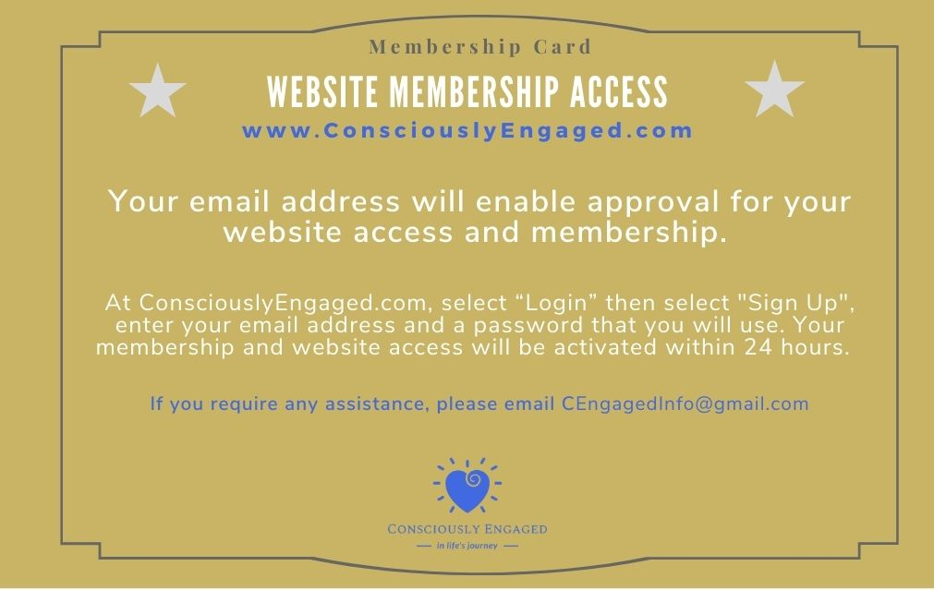
Enjoy!!

